Task Description:

Create the K8s EKS,further you have to do the deployment of the Nginx application and access the application outside the cluster.

1.EKS cluster created:
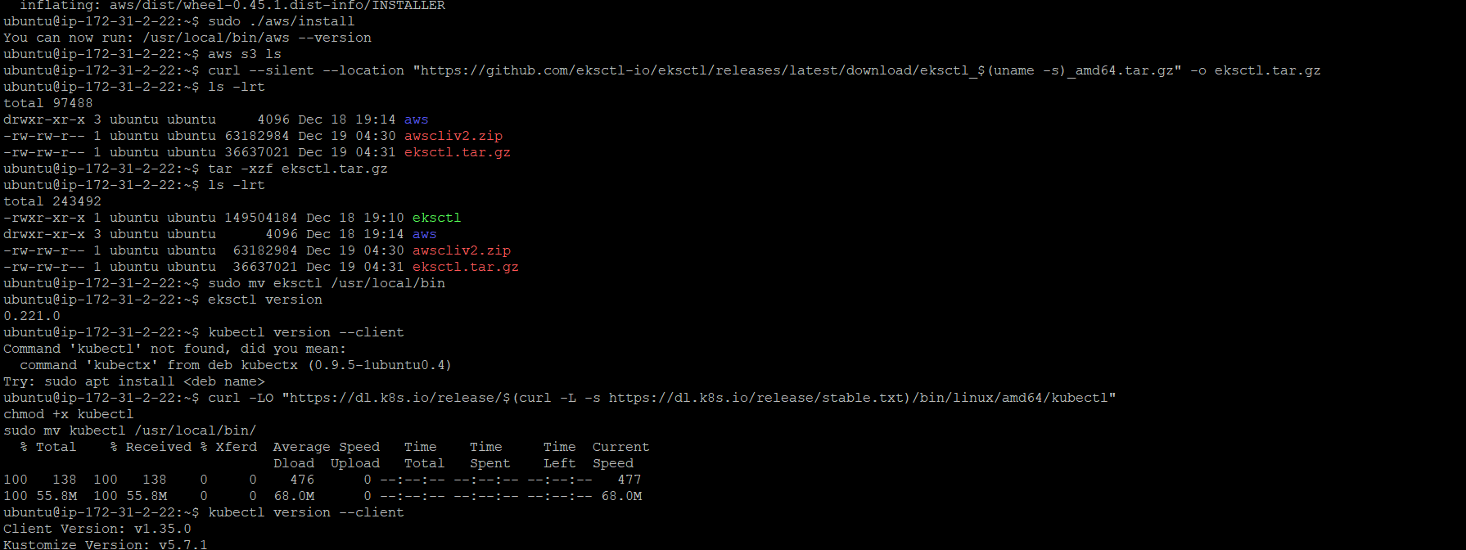

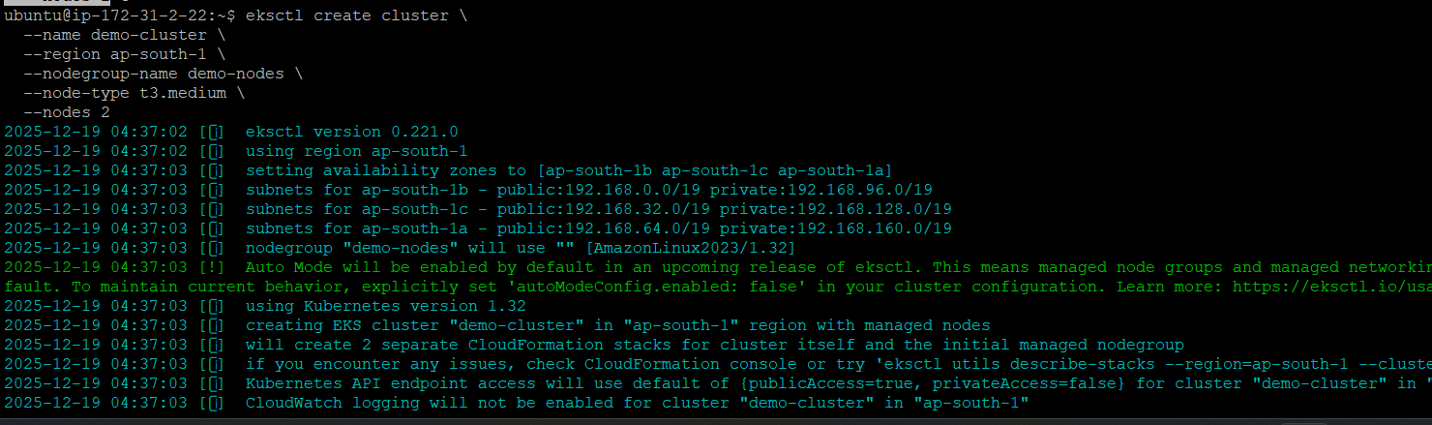
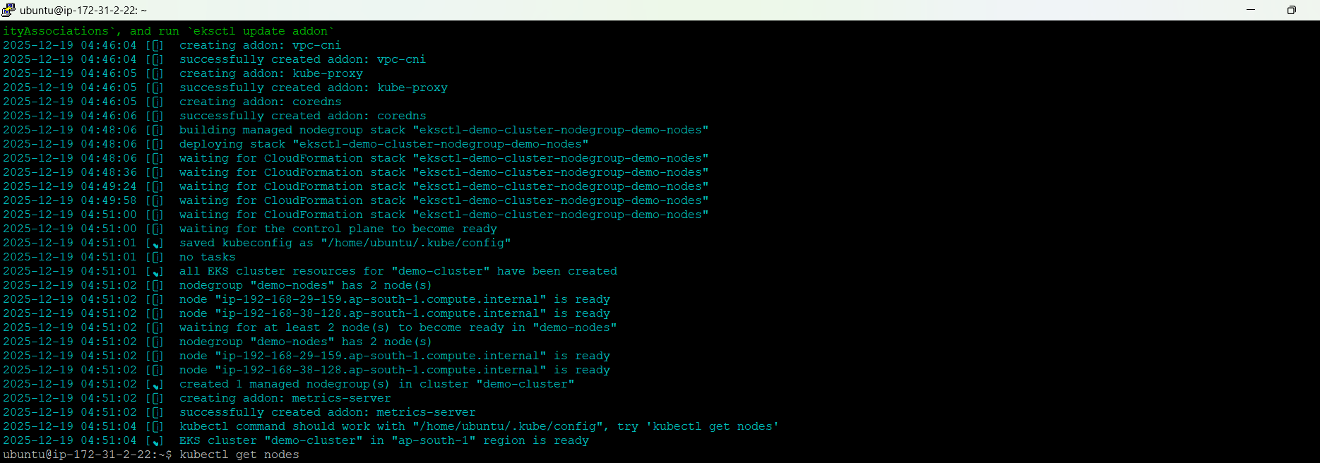
I got a Cloud formation stacks error in GUI since I have limited privilages.
But am able to see in server:
Two nodes created:
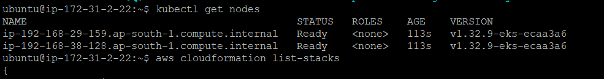
Cloud formation stacks :
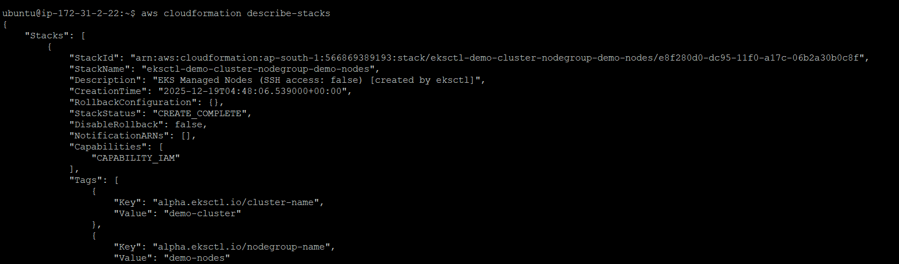
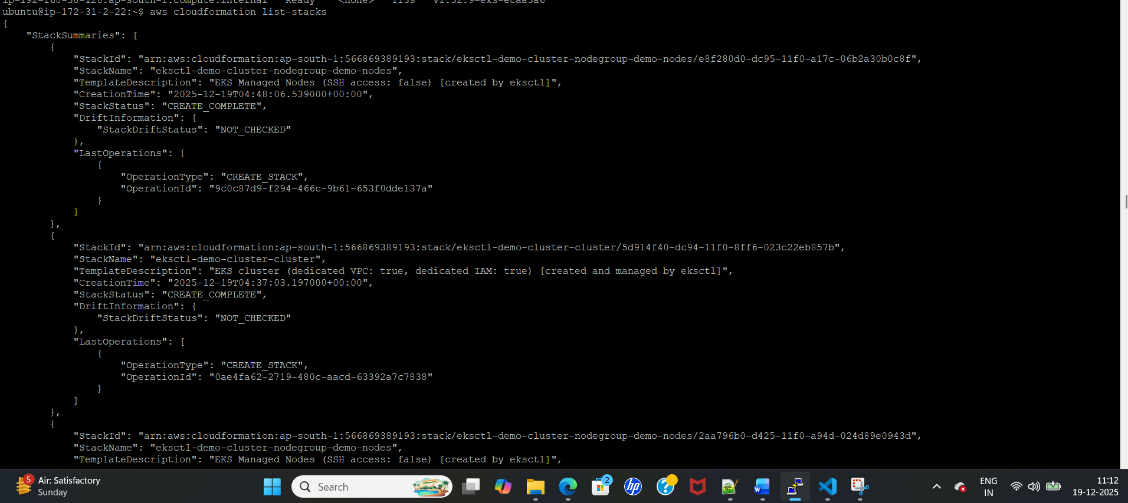
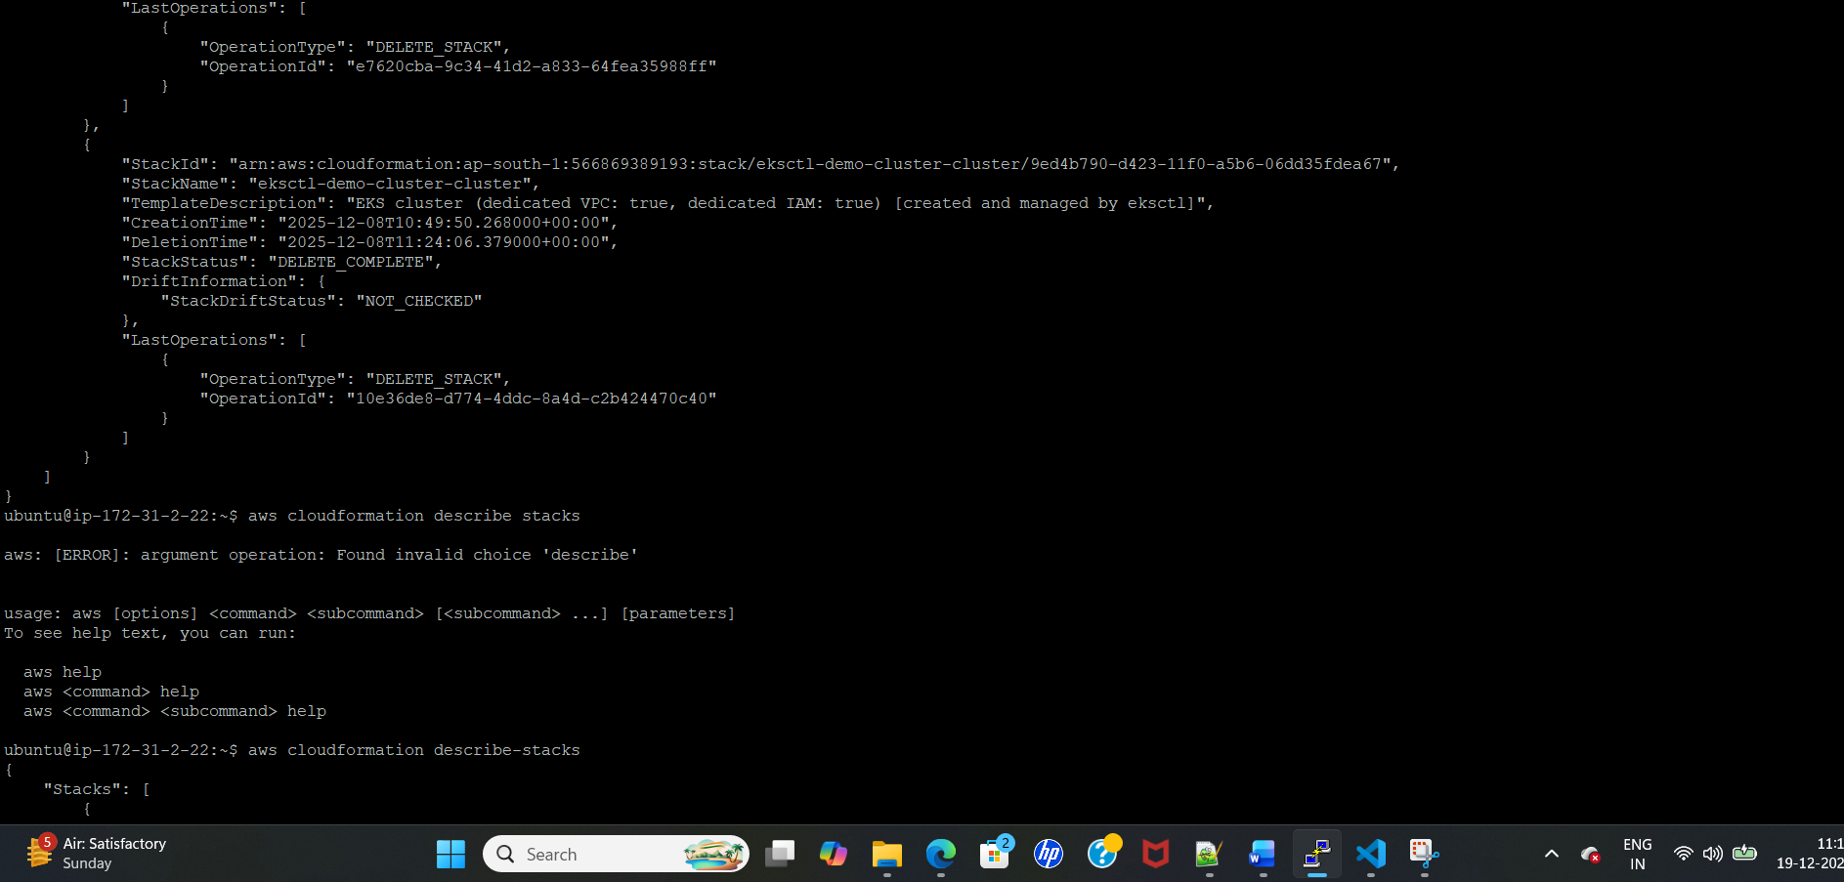
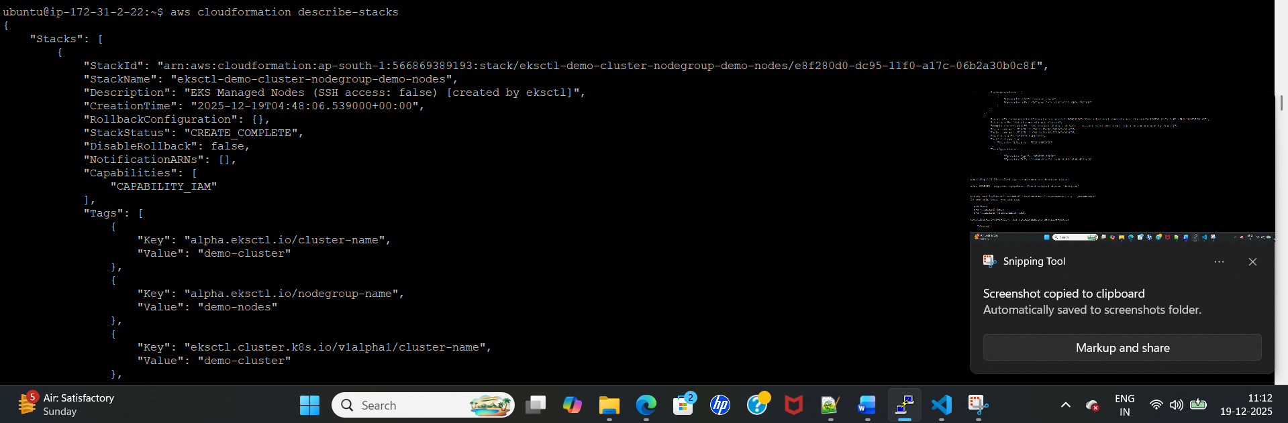

Total files created:
1.deployment
2.load balancer
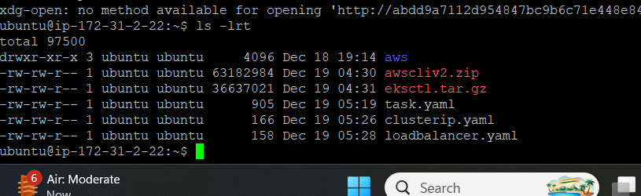
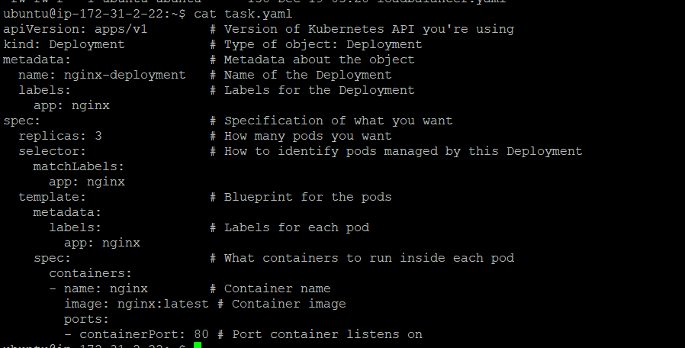
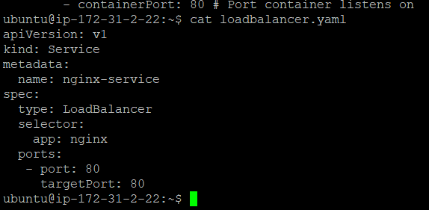

Pods created:
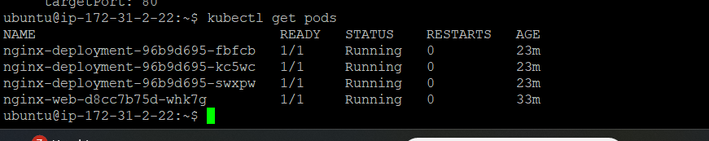

Service created : Loadbalancer
External ip will create based on the load balancer service
abdd9a7112d954847bc9b6c71e448e84-1553177305.ap-south-1.elb.amazonaws.com
or we can use the below commad:
http://abdd9a7112d954847bc9b6c71e448e84-1553177305.ap-south-1.elb.amazonaws.com'

Output:
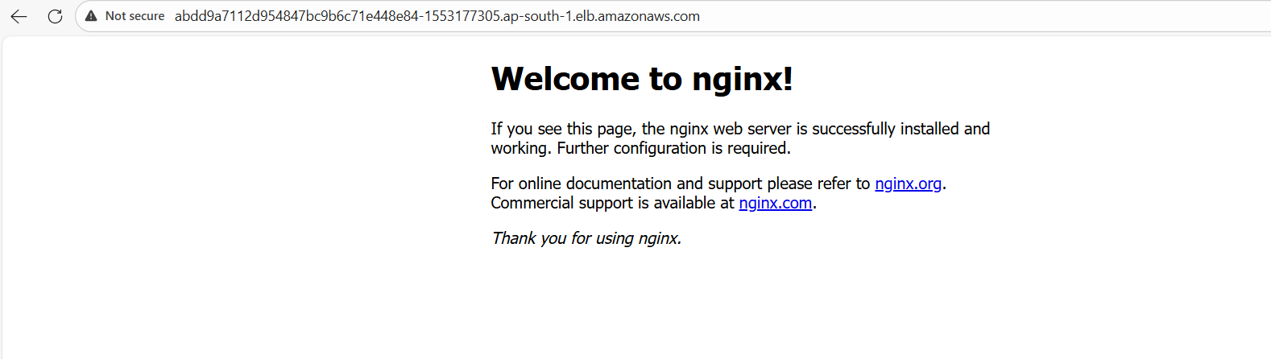

AWS:
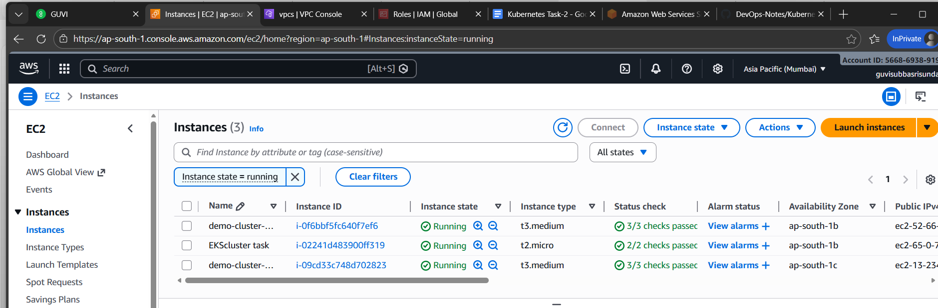
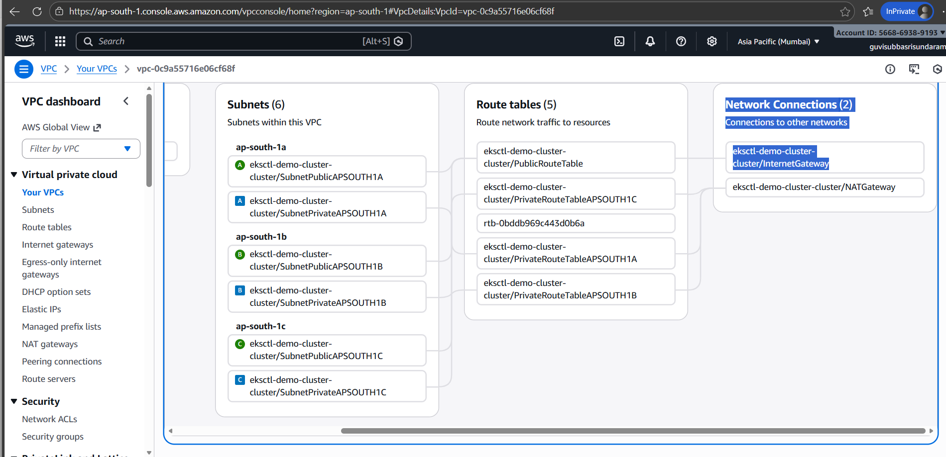
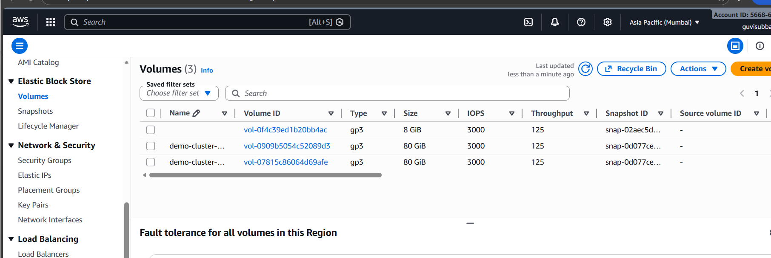

Load balancer:
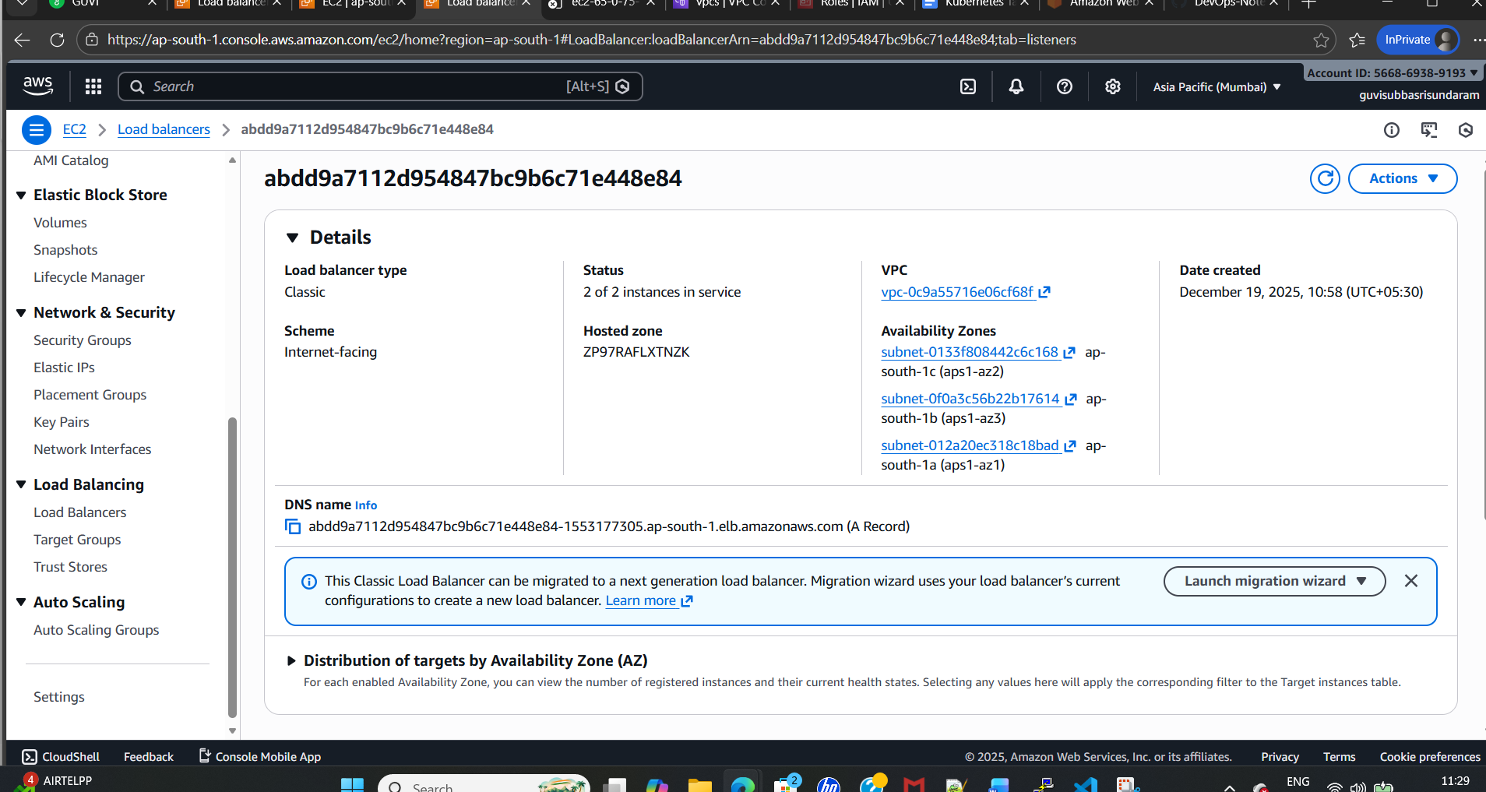
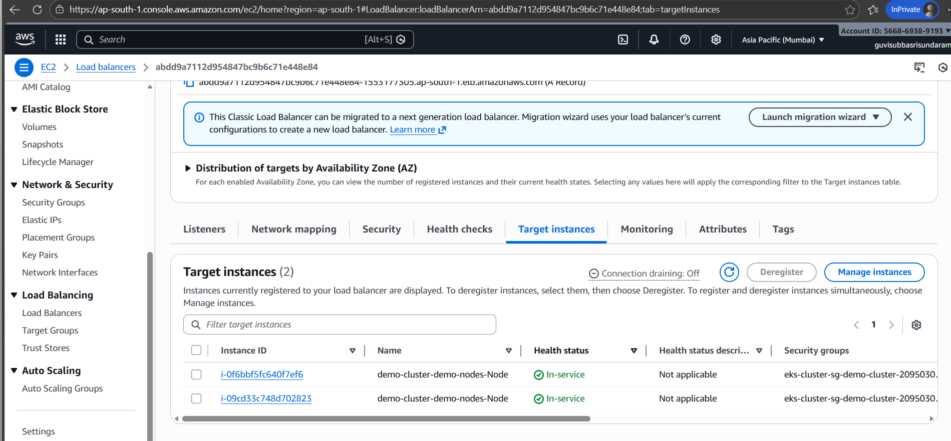
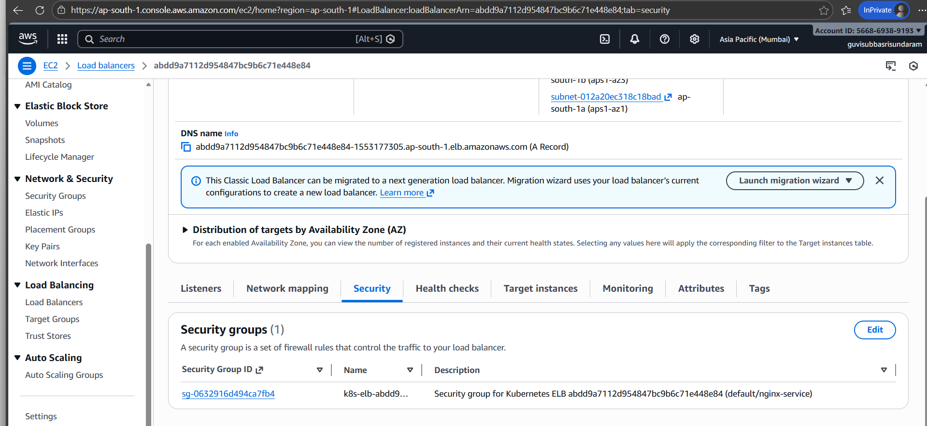
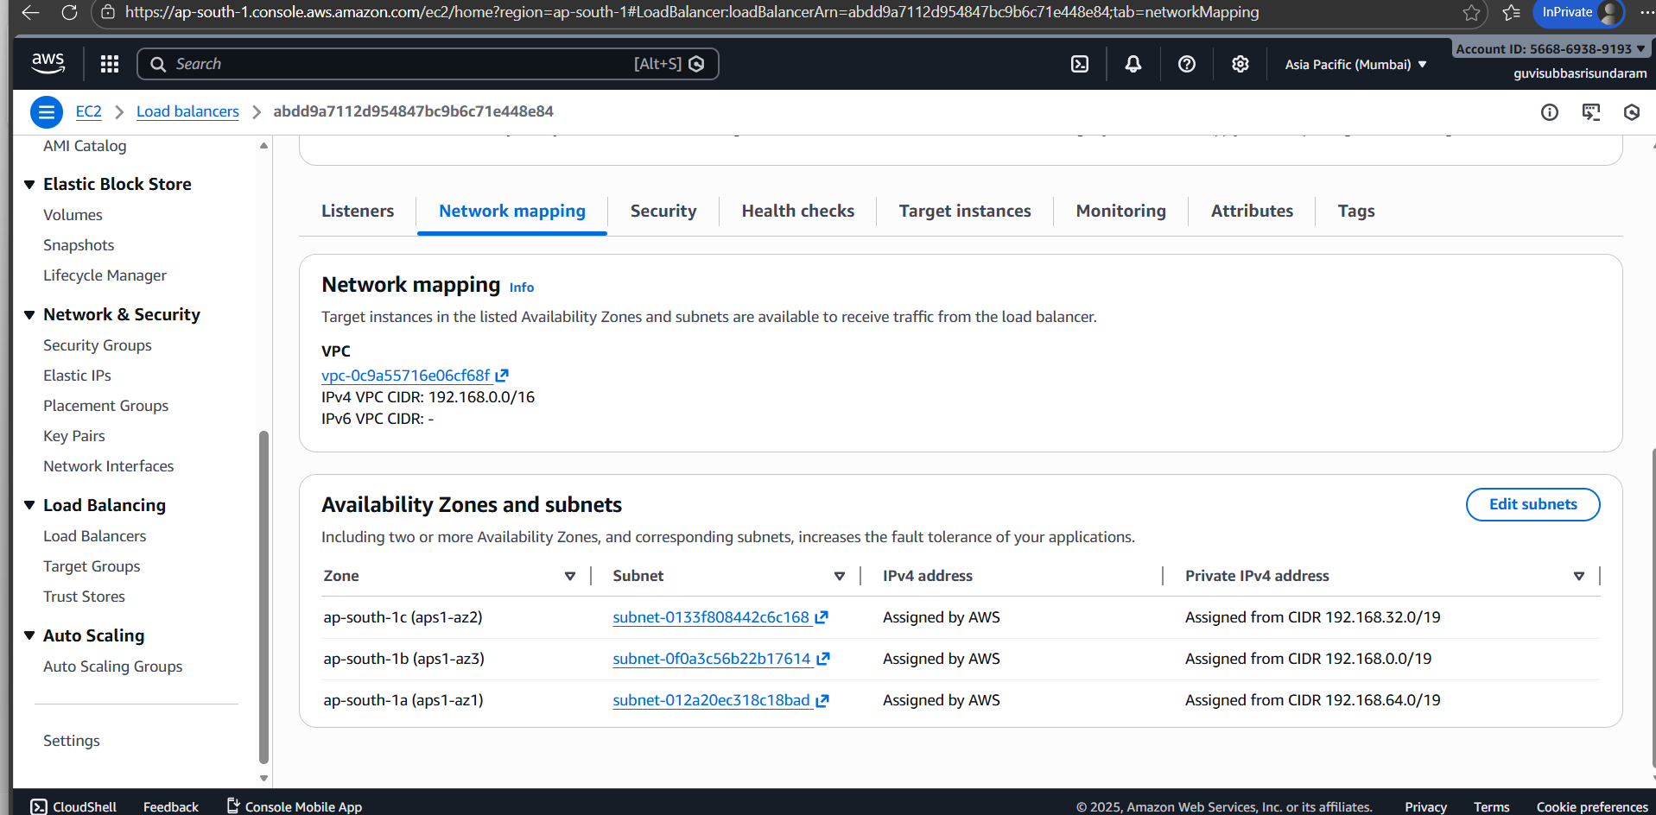

Delete cluster:
